VOCABULARY WORDS—3rd 9 weeks – CCGPS Analytic Geometry
Circumcenter --

Centroid --
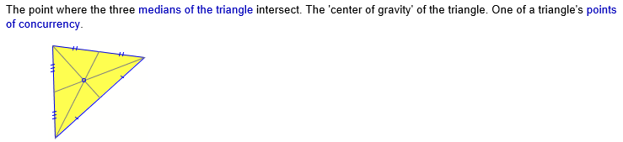
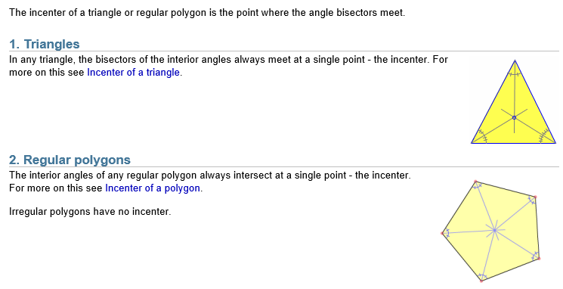
Incenter –

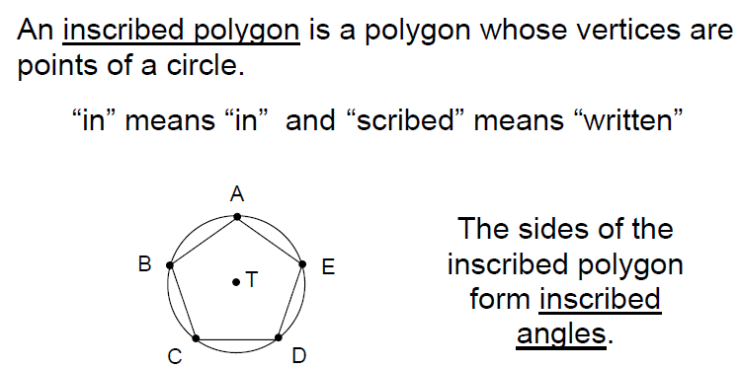
Inscribed Polygon—

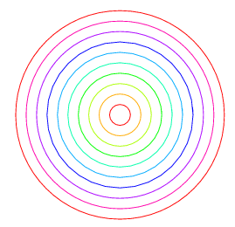
Concentric Circles –
Circles with the same center, but different radii.

Central Angles –
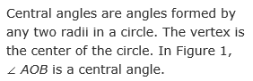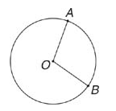

Inscribed Angle –
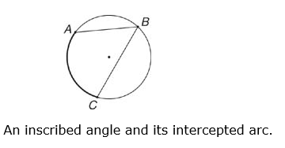
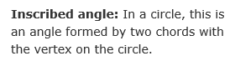

Intercepted Arc –
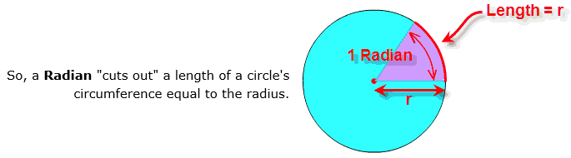
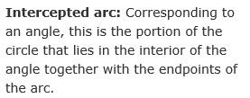
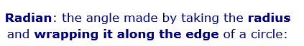
Radian --

